# PROJECT REPORT ON

**Alumini-Form & Project**



# BACHELOR OF COMPUTER APPLICATION

**(SESSION 2022-23)**

## Submitted To : Submitted By:

**Ms. Savita & Garima Nikhil Kumar**

**Roll-No: - 203032220049**

**(Asstt.Prof.Comp.Sci.Dept.)**

**Project Guide & Co-ordinator BCA 3rd Year**

**DEPARTMENT OF COMPUTER SCIENCE** CHHAJU RAM MEMORIAL JAT COLLEGE AFFILIATED TO GJUS&T, HISAR – 125001

# CERTIFICATE

This is to certify that **Nikhil Kumar**, Roll No.**203032220049** a bonafide student of Bachelor of Computer Applications program being run by **CRM Jat College**, HISAR of batch 2020-23 has complete the project entitled “**Alumini-Form& Project**” under our supervision and guidance. It is further certified that the work done in this project is a result of the candidate's own efforts. We wish him all success in his life.

**(Ms.Savita & Ms.Garima) (Asstt. Prof. Comp. Sci. Dept.) Hisar**

**Signature :**

# DECLARATION

I hereby certify that the work which is being presented in the project report entitled “**Alumini-Form & Project**” by “**Nikhil Kumar**” in partial fulfillment of requirement for the award of degree of BCA submitted in the Department of Computer Science & Applications, **CRM JAT College**, Hisar under “GURU JAMBHESHWAR UNIVERSITY OF SCIENCE AND TECHNOLOGY”, Hisar is an

authentic record of my own work carried out during a period from 2020-

23 under the supervision of **Ms.Savita & Ms.Garima Mam.** The matter presented in this project has not been submitted in any other University/Institute for the award of BCA Degree. This is to certify that the above statement made by the candidate is correct to the best of our knowledge.

**Nikhil Kumar**

# ACKNOWLEDGEMENT

The satisfaction that accompanies the successful completion of any task would be incomplete without the mention of people whose ceaseless cooperation made it possible, whose constant guidance and encouragement crown all Efforts with success. Every possible effort is dedicated to **Ms.Savita & Ms.Garima mam Asstt.Prof.Comp.Sci.Dept.** for giving me a new significance to our endowment regarding this project. I am highly indebted for the gestures, invaluable suggestions and boosting confidence to make this successful. I am thankful to my entire respected faculty members who were a great source of information and knowledge for me. For the guidance, inspiration and constructive suggestion that helped me in the preparation of this project. I dedicate my whole effort and success in this project to my parents and friends, who assisted me with all kinds of moral as well as monetary support throughout my project work. I also extend my apologies for all errors or omissions, which are solely my responsibility.

**Nikhil Kumar**

**Alumini-Form**



# CONTENT

1. INTRODUCTION : 2.OBJECTIVE:

3.Work Process 4.Modules Description

1. HARDWARE AND SOFTWARE REQUIREMENT :
2. TOOLS AND PLATFORM:
3. TECHNOLOGY USED IN THIS PROJECT :
   1. PHP:
   2. MySql Database
   3. HTML
   4. CSS
   5. JavaScript 8.Hosting : 9.Conlusion **:**
4. Future Scope
5. References

# INTRODUCTION

When I was a child, I faced many problems related to studying. The information I needed was scattered across different websites, and I had to spend a lot of time searching for the right data. Sometimes, even after hours of surfing the internet, I couldn't find the appropriate information I was looking for.

During exam times, the pressure to study was immense, and I often relied on online resources to supplement my learning. However, the process of finding reliable and relevant study materials was frustrating and time-consuming.

One day, as I reflected on my past experiences and the difficulties I encountered during exam preparations, an idea struck me. I realized that many other students must have faced similar problems and felt overwhelmed during exam season. That's when I came up with the idea of creating a website that would provide students with curated study materials, saving them valuable time and effort.

With this vision in mind, I embarked on developing a website called "Alumini-Form & Project." The primary goal of this website is to assist students in their exam preparation journey. To access the study materials on our website, students need to register and create an account. Once registered, they can easily browse through the available PDFs and other textual resources that are relevant to their courses or subjects.

If you have any suggestions or feedback on how we can improve our website further, please feel free to share. Together, we can empower students and enhance their educational experiences.

There we created a **“REGISTRATION FORM**” which is effective program providing a user friendly interface . It provide all the tasks required for Registration Form to get data from user or candidate. It displays various fields such as :

* Name
* Father’s Name
* E-mail
* Mobile
* Date of birth
* Password
* Caste
* Languages
* Photo of Candidate
* Photo of Signature
* Gender
* Bio

# OBJECTIVE :

In the current research aims at reducing the workload of all the entities involved in registration procedure for the students and individuals . In the current time we face various challenges as to maintaining the data manually. We fill form manually, which is very time consuming process. The main objective of this form are:

* To computerize data of the user.
* Maintainability of the data becomes easy.
* Reduces time and efforts.
* To maintain data consistency.
* To help the students by providing study related data at one place.
* Also provided New notifications from University and College.
* And also provide a Career Corner (Links of latest Jobs related to SSC ,HSSC,Central ,Banking and others).

# WORK PROCESS

We are following definite processes for website creation that involves various "modifications and keeping options for software expansion, should need arise in future. Here is a quick overview of the steps they follow :

* **Planning:** Firstly we select different topic which target more audience, then we choose to make a website which helps the students by providing study related data like PDFs and other tutorials. Where students register on our site and can access the data.
* **Designing:** There we use a basic model to design our website where firstly the students have to register and then login theirself. After that they can access the data according to their requirement.
* **Coding:** After planning and designing we code our website according to our design. We do coding by using different softwares like notepad,Visual studio code in different programming languages such as HTML, CSS etc.
* **Testing:** After code the website we test our website that our website works properly or not. For this we take different test cases to test the website. After testing, if our website works properly then we move to next step otherwise repeat above steps again.
* **Deployment:** After testing, we deploy the website on internet by using InfinityFree as a hosting platform and then connects our webpages by using PHP.
* **Maintainence:** At last we have to keep our website up-to-date and running smoothly as well as performing optimally. It includes tasks like ensuring all the links on your site are working, regularly updating content, and fixing any broken links.

**Waterfall Model**



# MODULES DESCRIPTION

Modules are the partitions of any project done to ease the task of development. Different modules are designed so that debugging and other development phase gets the easiest implementation .

In our project we use different modules with their different purpose. The different modules of the project are:

* Home page
* Notification
* About
* Services
* Contact
* Join Us
* Registration page
* Login-page

**Modules**

Alumini-form & Project

H

o m e

P

a g e

N

o ti fi c a ti o n

A

b o u t

S

e r v i c e s

C

o n t a c t

J

o i n

u s

R

e g i s t r a ti o n

L

o g i n

P

a g e

**Home Page**

Our home page show the Sign in, Navbar and SignUp options. To give any upload or access data you have to Sign in to the site and then proceed to the next step.

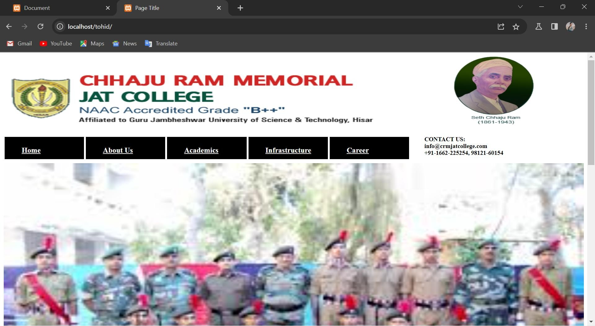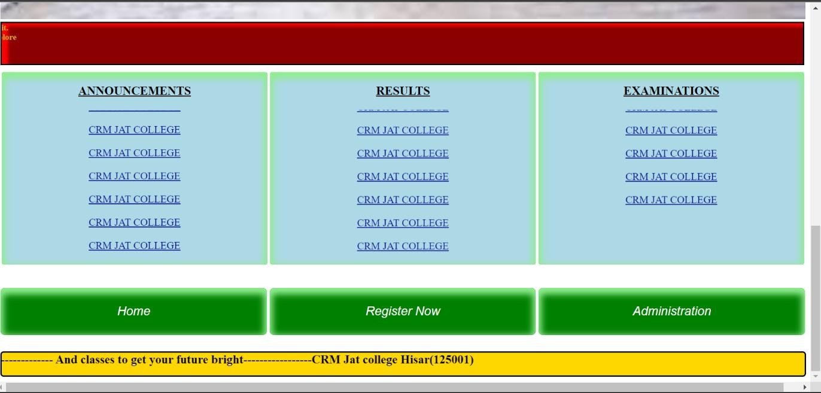

**Notification**

On our home page we provide notifications related any announcements, results and examination where we provide latest information about newly updated data

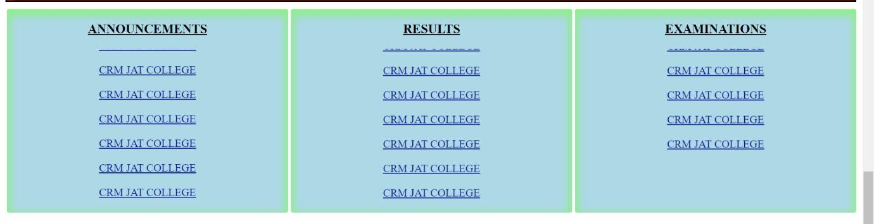

**About**

Here we provide study material that helps the students to make a bright future in language world.

Study material like:-

#notes

#practicals #softcopy of book& #assignment& #important questions #previous paper #helpful videos

**Contact**

Also there is contact button in the navbar on our home page where we provide our contacts number and email id’s . So students can contacts us for any query related to our website and also can give advise to us to make our website more efficient. There are different methods through students can contact us. These are:

1. E-mail
2. Calling 

**Registaion Page**

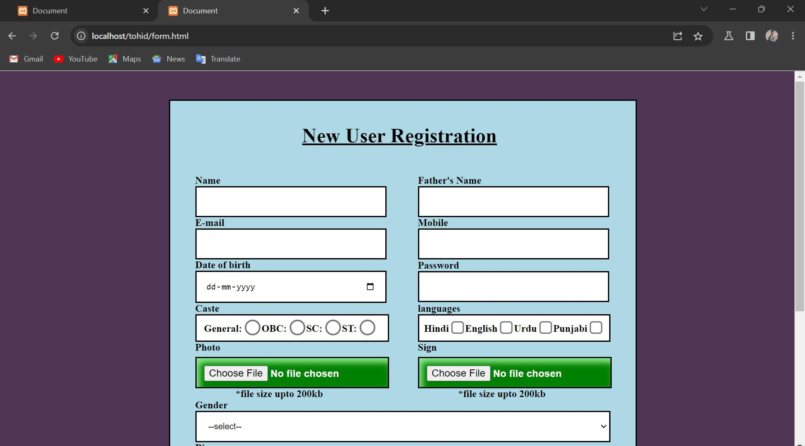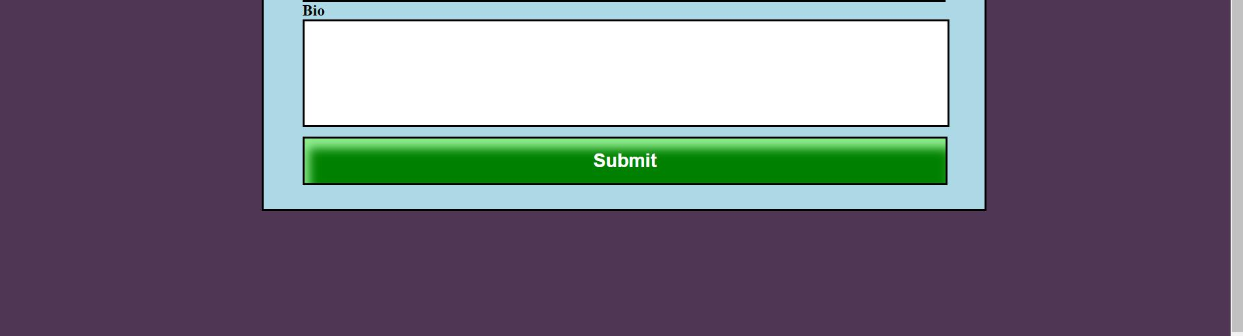

For unregistered user: The register page prompts the user to enter their personal details along with a email address and password. The page has validation features implemented to check the format of the email .The page also checks for the new registrant to have a unique email address by checking the database for a match against the existing email address.

**Login Page**

For registered user:If user is already registered then they will be able to access the data and also can upload notes and PDFs by admin who can Login in on home page. It also allows the admin to deal or interact with the user for any updation.

# HARDWARE & SOFTWARE REQUIREMENT

### (Recommended) # Hardware: -

**Processor Pentium 4(P4) Processor speed 2.08 Ghz Hard Disk 16 GB**

**Ram memory 4GB**

### # Software: -

**Operating System Window 8, Linux, Android,**

**MAC**

**Web Browser Any Web Browser**

# TOOLS & PLATFORM

This project is developed using this tool, which are most suited for this project. These tools are as follow: -

### Visual Studio Code

* **Firefox Browser**

### Chrome Browser

* **Infinity Free Website**

### Infinity SQL

* **Visual Studio Code :** Visual Studio Code is a streamlined code editor with support for development operations like debugging, task running, and version control. It aims to provide just the tools a developer needs for a quick code-build-debug cycle and leaves more complex workflows to fuller featured IDEs, such as [Visual Studio IDE](https://visualstudio.microsoft.com/). We are currently work on its 1.773 version.

VS Code runs on macOS, Linux, and Windows. VS Code runs on macOS, Linux, and Windows. VS Code gives you the option to install Microsoft and third party extensions. These extensions may be collecting their own usage data.

Beyond crash reporting and telemetry, VS Code uses online services for various other purposes such as downloading product updates, finding, installing, and updating extensions, or providing Natural Language Search within the Settings editor.

* **Firefox Browser : Mozilla Firefox** is an open-source web browser that is used to access the data available on the World Wide Web. As compared to Internet Explorer, the popular Web browser Firefox provides users a simple user interface and faster download speeds. It uses the Gecko layout engine to translate web pages, which executes current and predicted web standards.

Firefox was widely used as an alternative to [**Internet**](https://www.javatpoint.com/internet) Explorer 6.0 as it provided user protection against spyware and malicious websites. In the year of 2017, it was the fourth-most widely used web browser after Google Chrome, Apple Safari, and UC Browser**.**

* **Chrome Browser : Google Chrome** is an open-source and the most popular internet browser that is used for accessing the information

available on the World Wide Web. It was developed by Google on 11 December 2008 for Windows, Linux, Mac OS X, Android, and iOS operating systems. It uses sandboxing-based approach to provide Web security. Furthermore, it also supports web standards like [HTML5](https://www.javatpoint.com/html5-tutorial) and [CSS](https://www.javatpoint.com/css-tutorial) (cascading style sheet).

Google Chrome was the first web browser that has a feature to combine the search box and address bar, that was adopted by most competitors. In 2010, Google introduced the Chrome Web Store, where users can buy and install Web-based applications

* **Infinity Free : Infinityfree** offers free web hosting with impressive marketing of unlimited disk space, bandwidth, and domain hosting. This, in theory, means you can host as many files as you want on your account server, have as many users visit your site as you want, and have as many primary web addresses as you want.

InfinityFree offers three shared hosting (opens in new tab) plans only, one of which is completely free-of-charge. It is titled “Infinity Free'' and it should include unlimited disk space, unlimited bandwidth (although it is limited to 50,000 daily hits), and unlimited hosting domains

### Specifications:

* + Unlimited Disk Space & Bandwidth
  + Free SSL
  + 400 MySQL Databases
  + Ad-Free Hosting

Free DNS Service

**Upload files**

**Enquiry**

**Support**

**Contact**

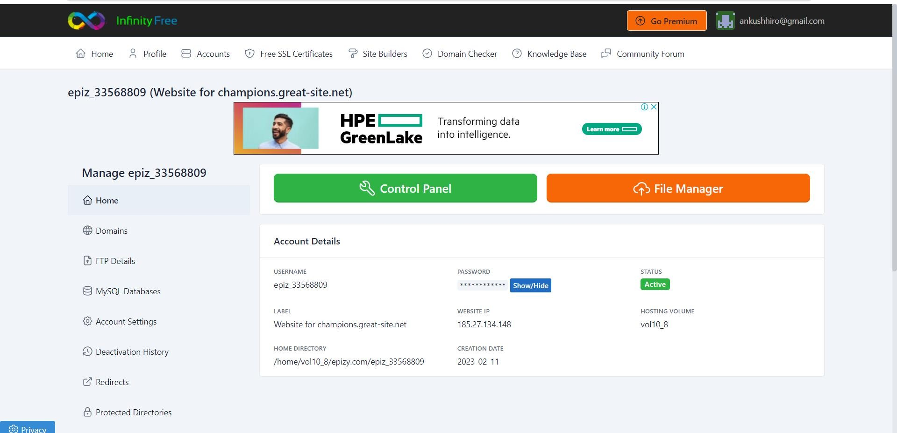

**Use-Case Diagram**

Admi

nistra tion

**Registraion**

**Manage files**

**Login**

1. **TECHNOLOGY USED IN THIS PROJECT**

We have developed this project using the below technology:

**Backend** – **PHP Database - MySql**

**Frontend- HTML, CSS, JavaScript**

 PHP is a recursive acronym for "PHP: Hypertext Preprocessor". PHP is a server side scripting language that is embedded in HTML. It is used to manage dynamic content, databases, session tracking, even build entire e-commerce sites.

* **JavaScript:** JavaScript (JS) is a lightweight, interpreted, or just-in- time compiled programming language with first-class functions. All the validation task and animations has been developed by JavaScript
* **HTML:** Page layout has been designed in HTML
* **CSS:** CSS has been used for all the designing part
* **Mysql Database:** MySQL is a relational database that uses structured query language. Relational databases are a type of database that uses a structure that allows us to identify and access the data in relation to another piece of data inside of the database. This format is often organized as tables.



# PHP

**PHP :** PHP can actually do anything related to server-side scripting or more popularly known as the backend of a website. For example, PHP can receive data from forms, generate dynamic page content, can work with databases, create sessions, send and receive cookies, send emails, etc. There are also many hash functions available in PHP to encrypt users’ data which makes PHP secure and reliable to be used as a server-side scripting language. So these are some of PHP’s abilities that make it suitable to be used as a server-side scripting language. You will get to know more of these abilities in further tutorials.

Even if the above abilities do not convince you of PHP, there are some more features of PHP. PHP can run on all major operating systems like Windows, Linux, Unix, Mac OS X, etc. Almost all of the major servers available today like Apache supports PHP.

### Work Done by PHP :

* + PHP can generate dynamic page content.
  + PHP can create, open, read, write, delete, and close files on the server.
  + PHP can collect form data.
  + PHP can send and receive cookies.
  + PHP can add, delete, modify data in your database.
  + PHP can be used to control user-access.

**Advantages of PHP**

* + **Scalable :** PHP is that it is scalable, it means the people coming to your website won’t experience long wait times.
  + **Free to use :** PHP is free to use, which means wer can use its frameworks, syntax, libraries,databases and all of its functionalities for free.
  + **Community support :** PHP community is the best community in the world in web development. If you are stuck in a problem then you got many solutions for this.
  + **Ease of use :** Syntax of PHP is simple and everyone can use it and learn it easily.
  + **Lightning speed :** The biggest advantage of PHP is its lightening speed. According to some experts the speed of PHP is three times the Python.



### Backend Code IN PHP

**Connection and Insert Data**

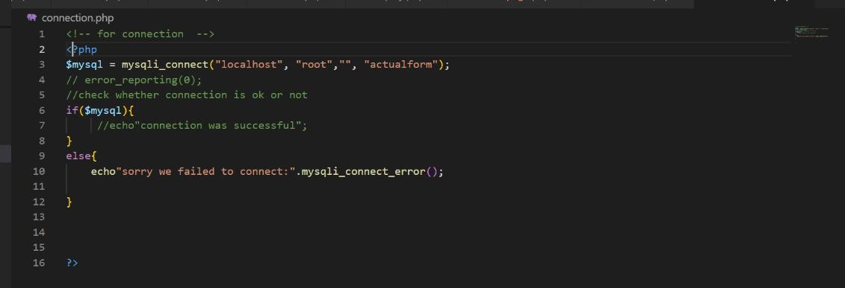

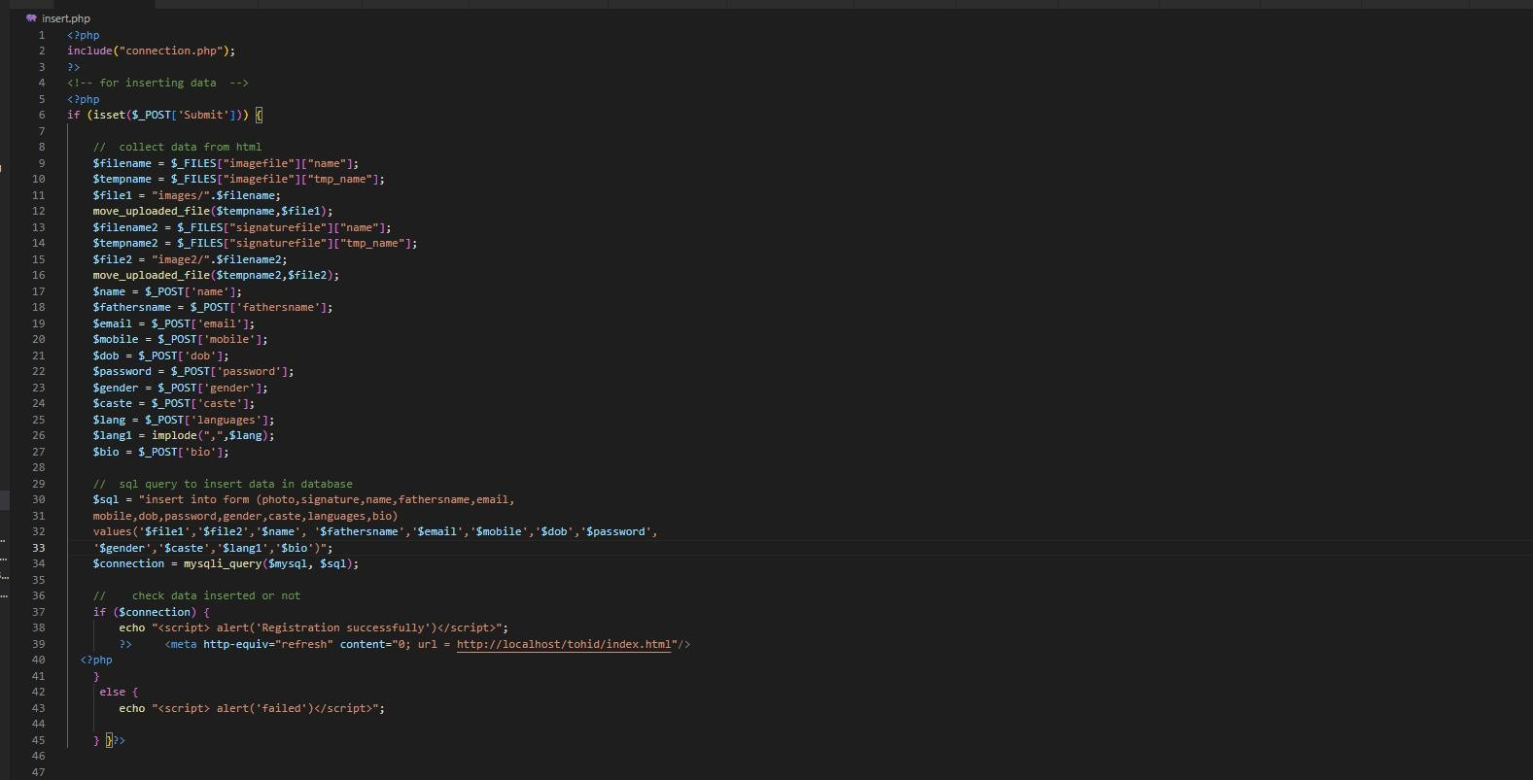

### Display Data

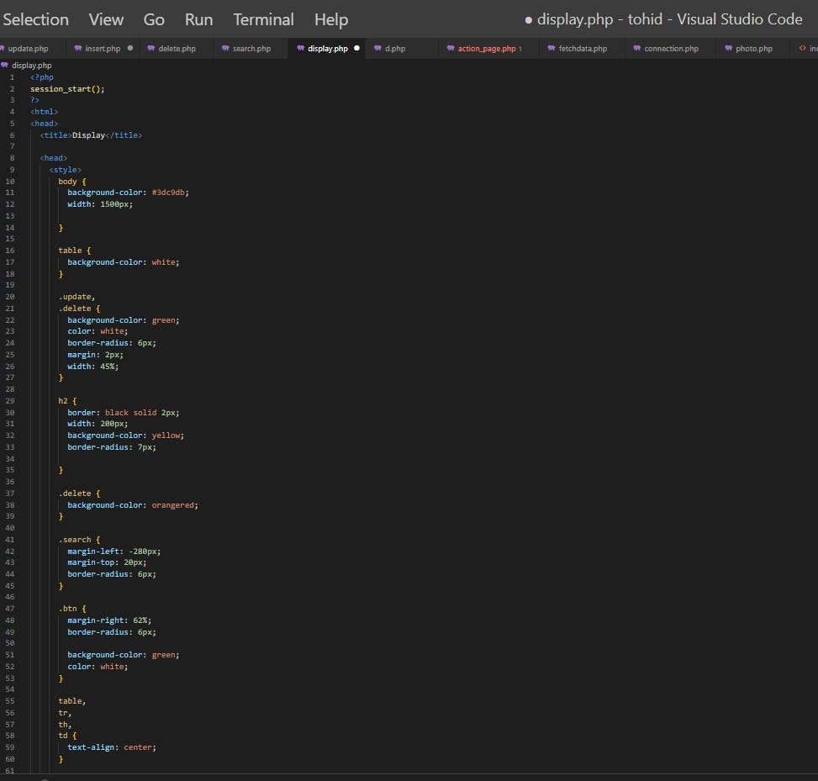

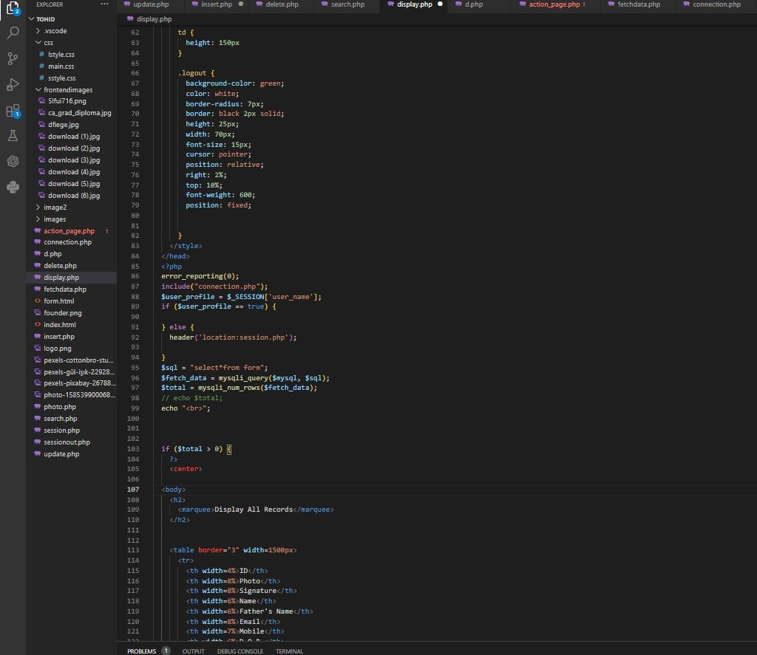

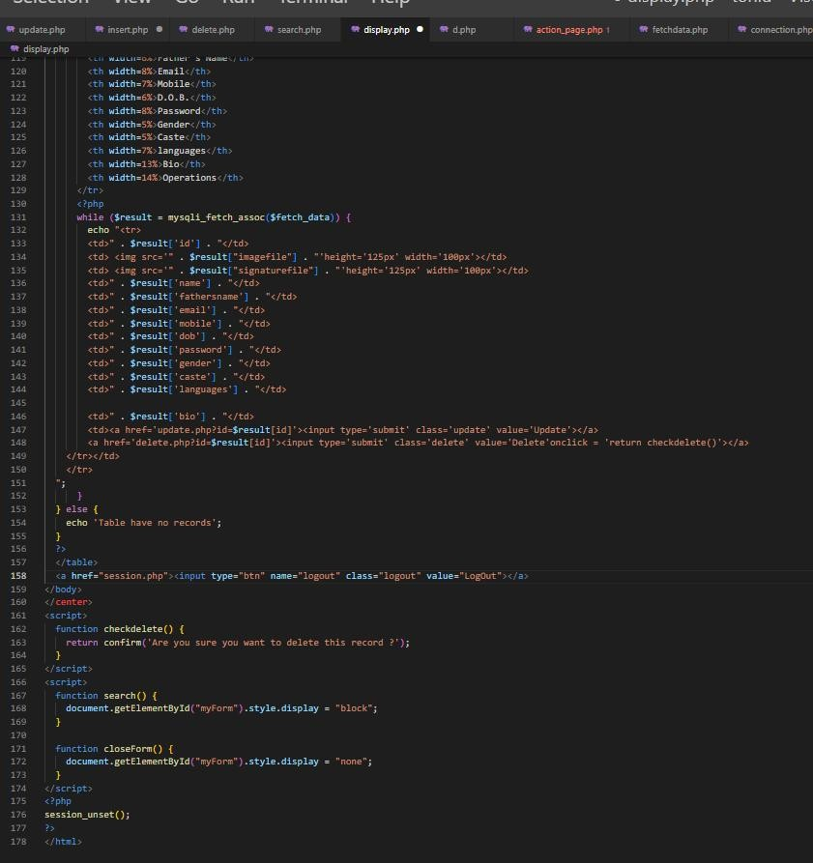

**Update Data**

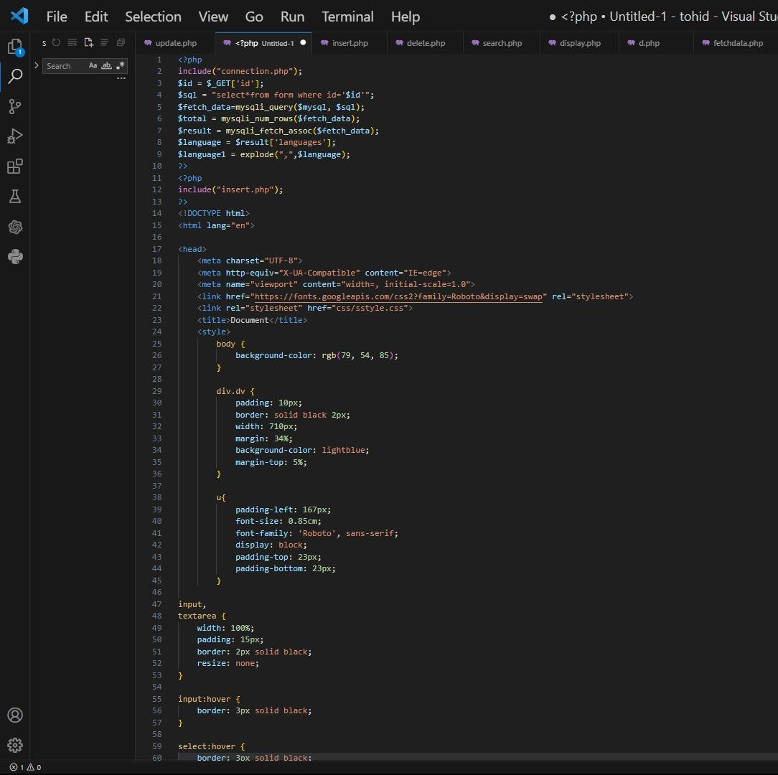

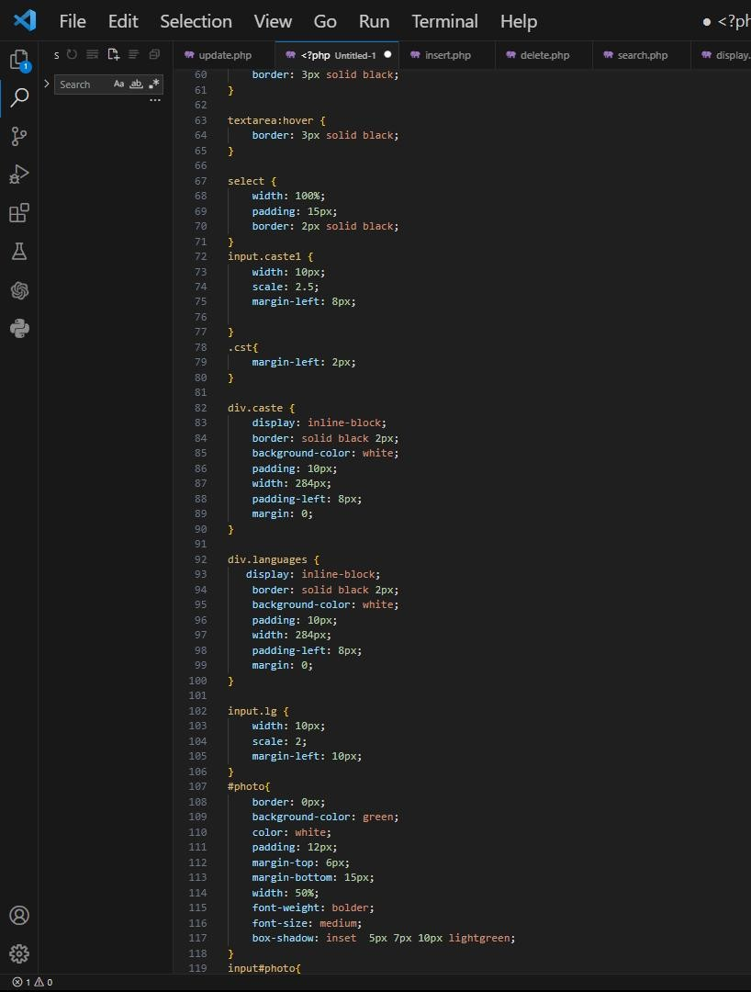

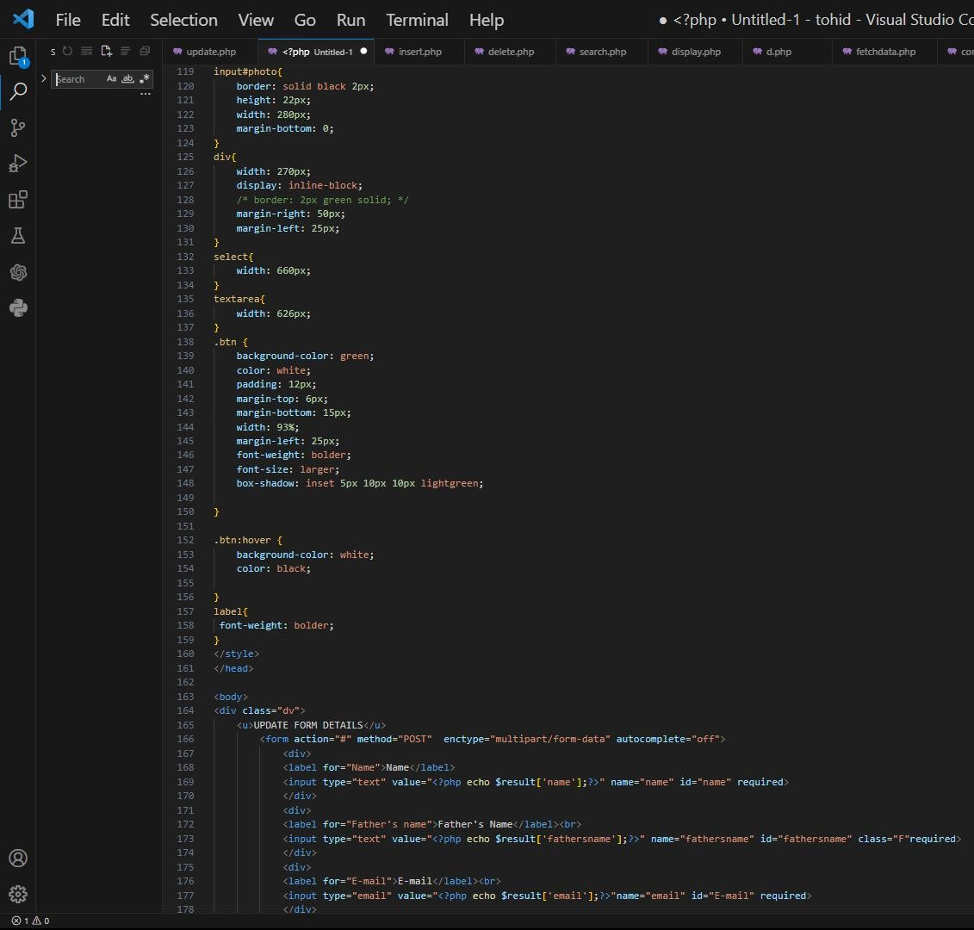

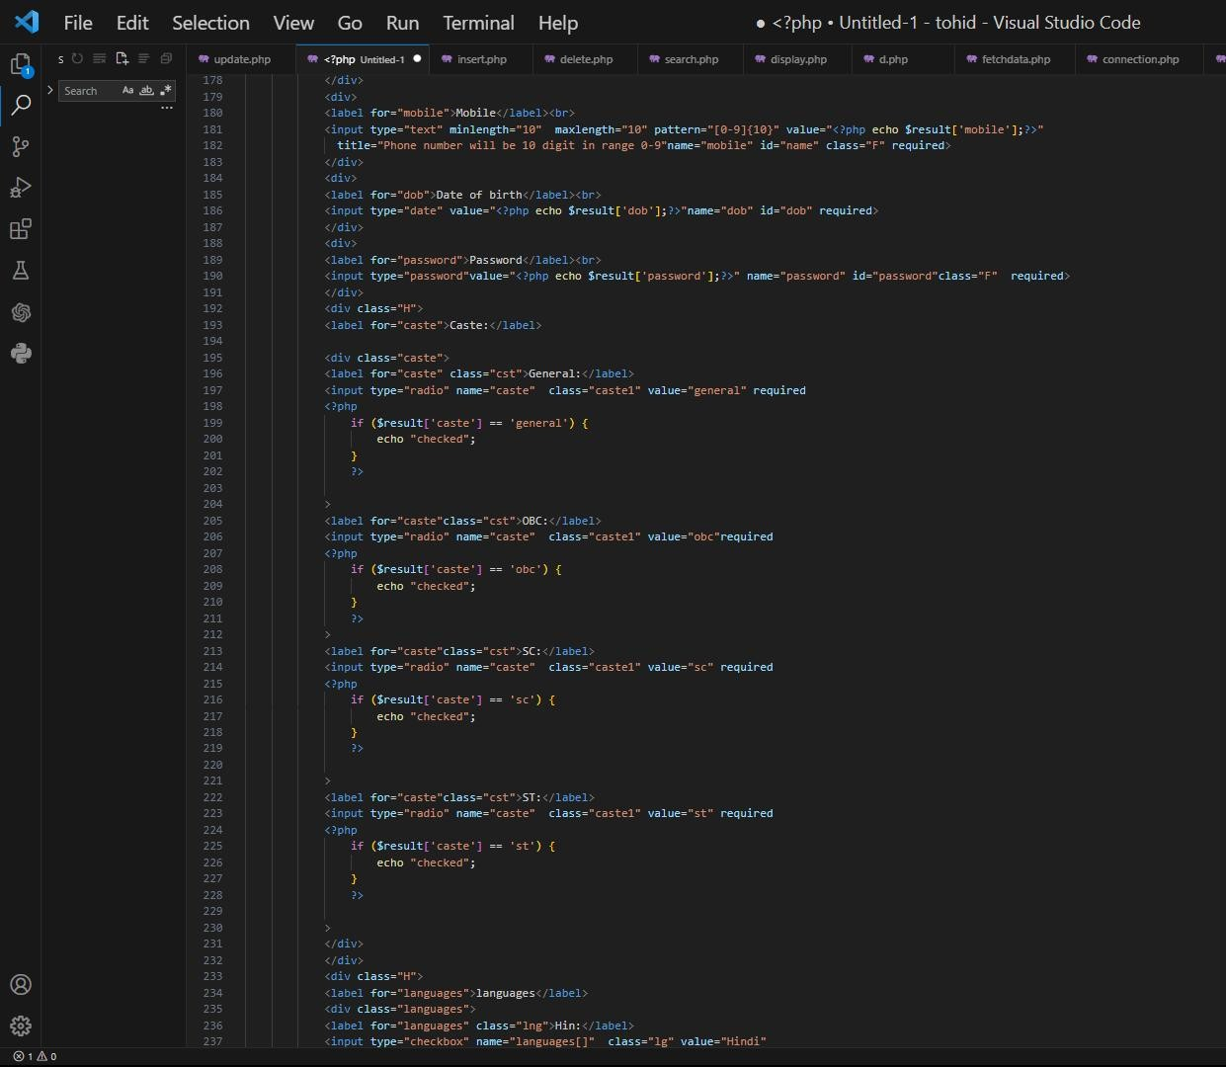

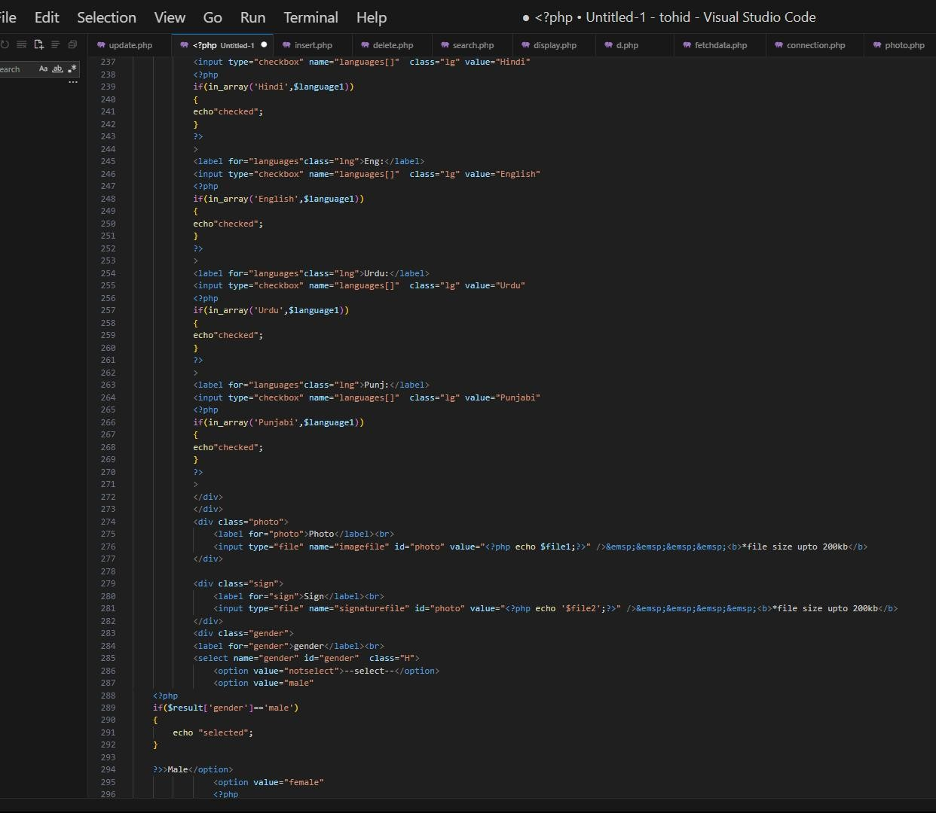

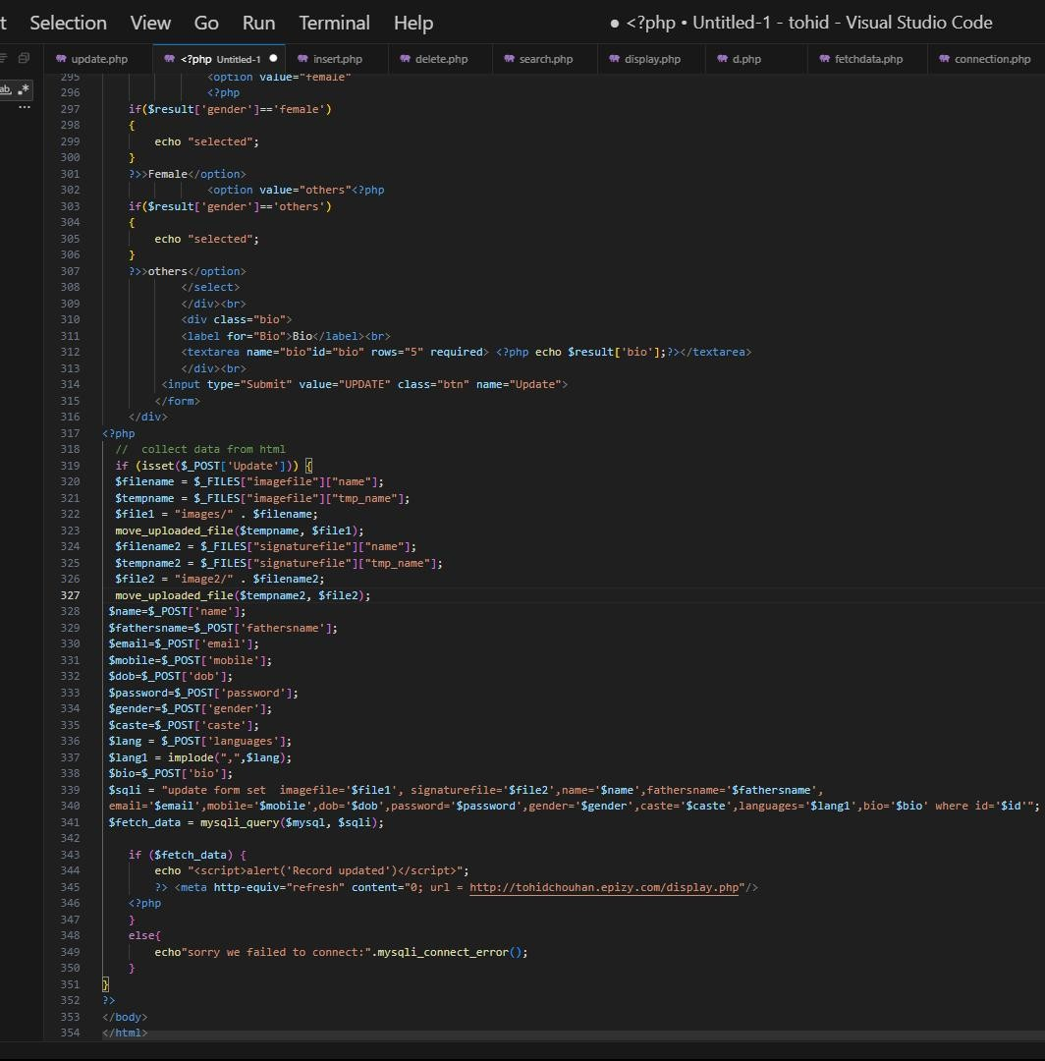

### Delelte Data

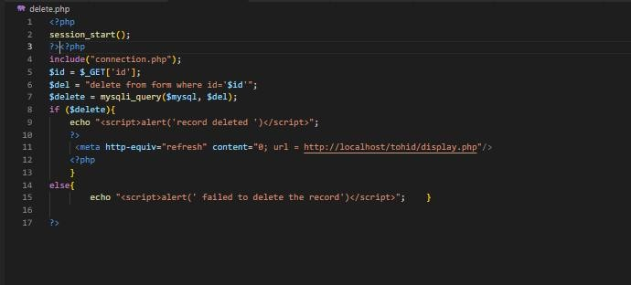

**Login page**

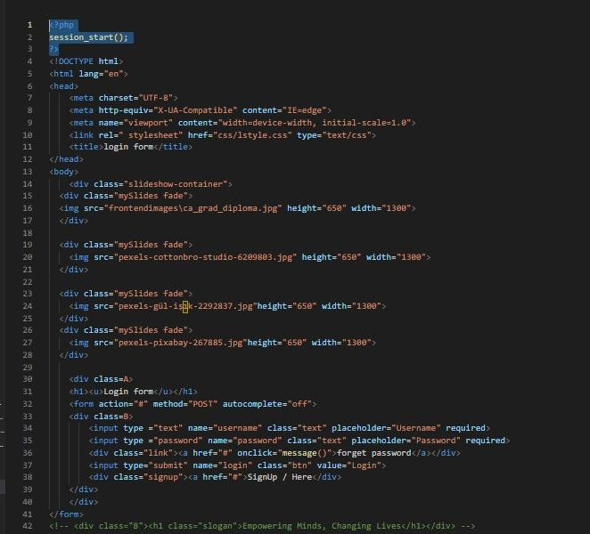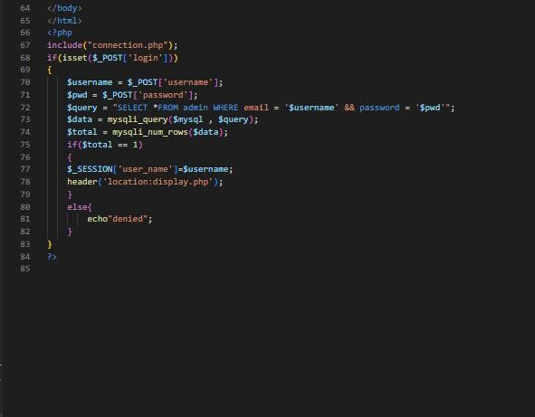

# MYSQL Database

We use the database of infinity free with MySql because it provide a free data storage.

**MYSQL Database:** MySQL is currently the most popular database management system software used for managing the relational database. It is open-source database software, which is supported by Oracle Company. It is fast, scalable, and easy to use database management system in comparison with Microsoft SQL Server and Oracle Database. It is commonly used in conjunction with [PHP](https://www.javatpoint.com/php-tutorial) scripts for creating powerful and dynamic server-side or web-based enterprise applications.

### How MySQL Works?

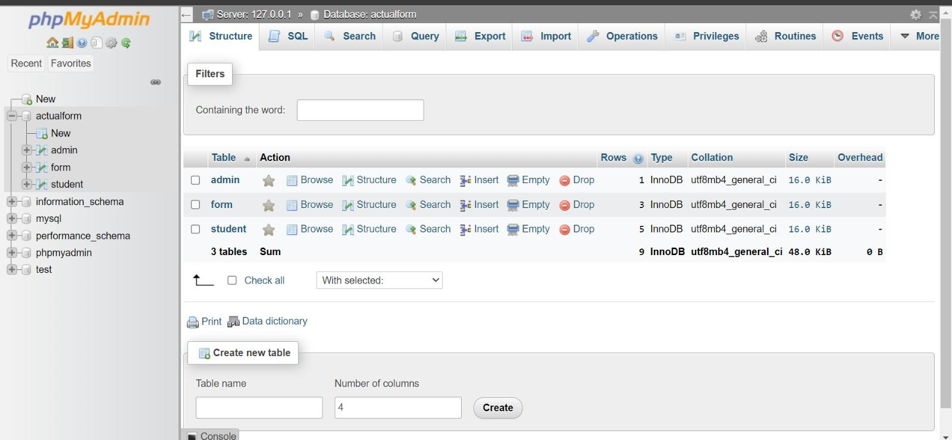

MySQL follows the working of Client-Server Architecture. This model is designed for the end-users called clients to access the resources from a central computer known as a server using network services. Here, the clients make requests through a graphical user interface (GUI), and the

server will give the desired output as soon as the instructions are matched. The process of MySQL environment is the same as the client- server model.

In **“Alumini-Form& Project”** we create two different tables to store the data in the Database. Following are the information of these tables:

1. **Form Table :** This table is used to get the users data for further requirements or to register on our site. There is seven fields in this table to registration on our website. These fields or attributes are as follows:
   1. Name:- Here the user inputs their own choice name which can be a combination of alpha(A-Z,a-z) numeric(0-9).
   2. Father’s Name:- Here the user inputs their own choice father’s name which can be a combination of alpha(A-Z,a-z) numeric(0-9).
   3. Email :- User provides their email I’d which is also a primary key.
   4. Mobile :- User enter their contact number with a specific country code.For eg. +91 9728696398.
   5. Date of Birth :- User enters their dob in the format of (mm/dd/yyyy).
   6. Password :- There user create a password within a specific combination of letters, numbers and special characters.
   7. Caste :- Here the user provides his caste which he belongs to .
   8. Languages :-Here the user provides the languages which is spoken by the user.
   9. Photo file :- Here the user provide the photo and the database store its path to access it.
   10. Signature file :- Here the user provide the photo and the database store its path to access it.
   11. Gender :- Here the user tells his gender.
   12. Bio :- Here user define himself in some words.

Following image is the structure of form table with all of its attributes:

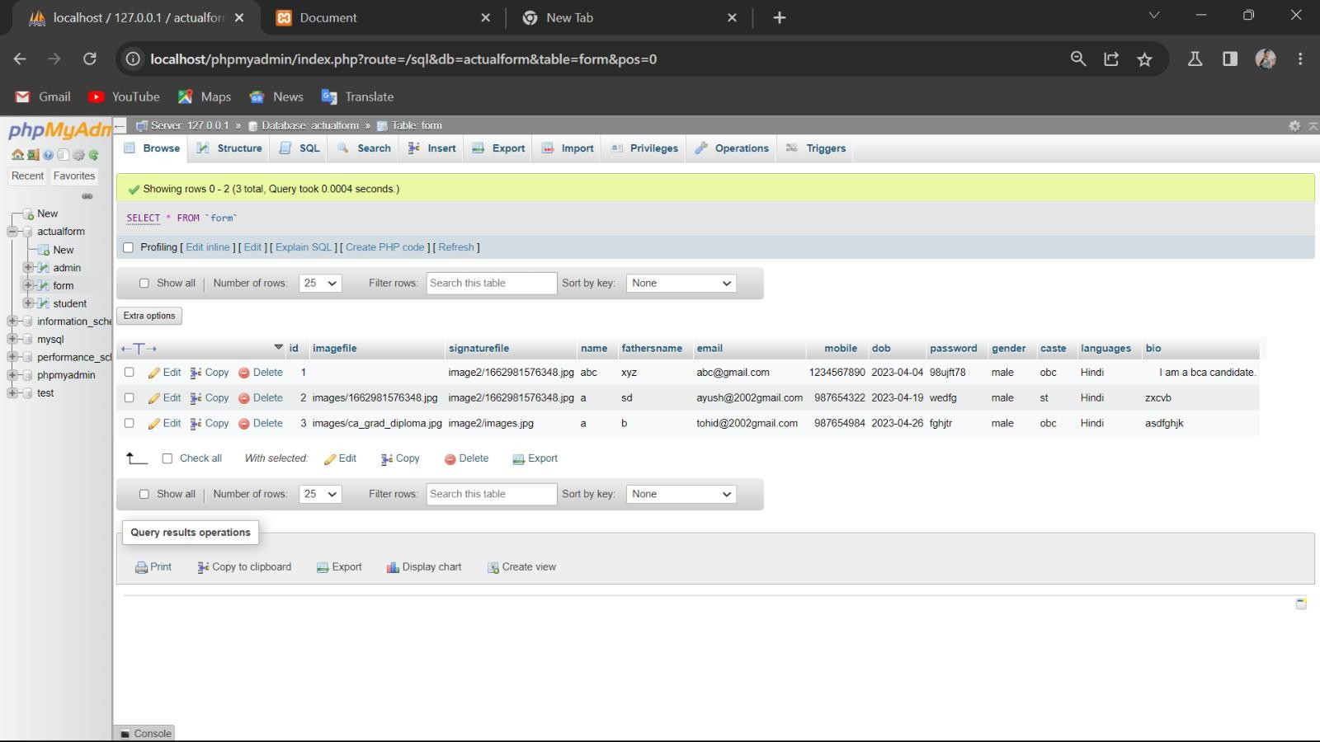

1. **Admin Table :** This table is created for storing and matching the input data of users. There is two fields in this table to login in our website and to get the access the data. These fields or attributes are as follows:
   1. Email :- Here the user enter the registered Email address to get access in the format of ( [abc@gmail.com](mailto:abc@gmail.com) ).And also Email treated as a **Primary Key**.
   2. Password :- Here the user input the own defined password which they give during the registration time.

Following image is the structure of table with its attributes:

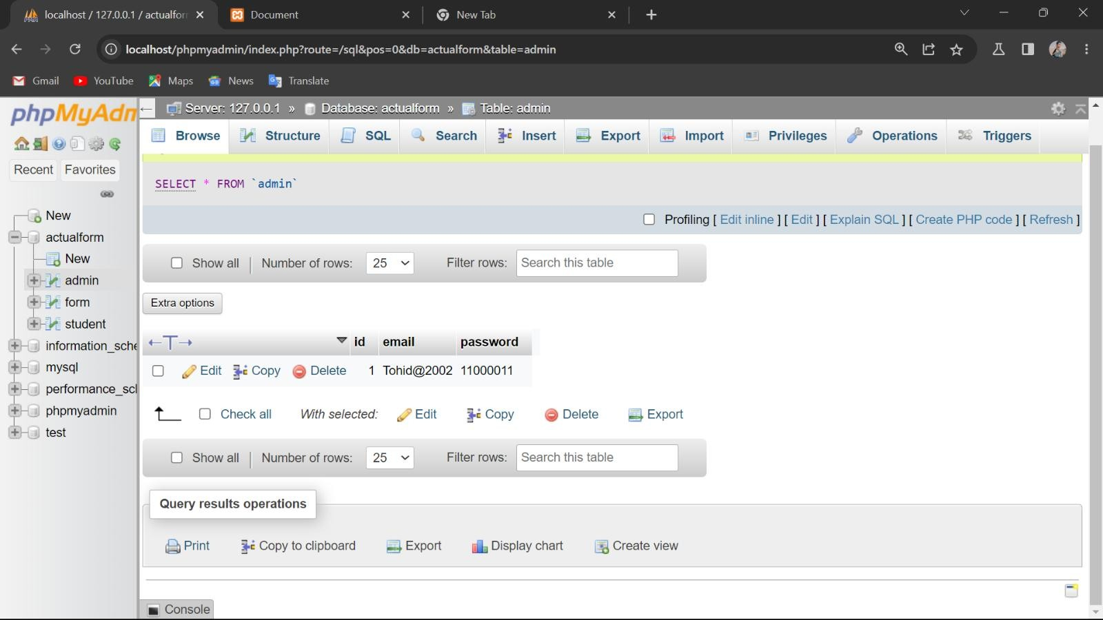



# HTML

Hyper Text Markup Language, commonly referred to as HTML, is the standard markup language used to create web pages. Along with CSS, and JavaScript, HTML is a cornerstone Stechnology, used by most websites to create visually engaging web pages, user interfaces for web applications, and user interfaces for many mobile applications. Web browsers can read HTML files and render them into visible or audible web pages.

HTML describes the structure of a website semantically along with cues for presentation, making it a markup language, rather than a programming language. HTML elements form the building blocks of all websites.

To do work with HTML we have to know about tags. Basically there are two types of tags:-

1. Empty Tags :- Empty tags are those tags that only have an

<Br>opening tag. E.g.:- <Br>, <link>, <img> & <hr> etc.

1. Containor Tags :- Container tags are those tags that have both

<B>opening and </B>closing tags. E.g.:- <**B**>, <*I*>, <U>,

<head> and <body> etc.

### HTML Code / Input:-

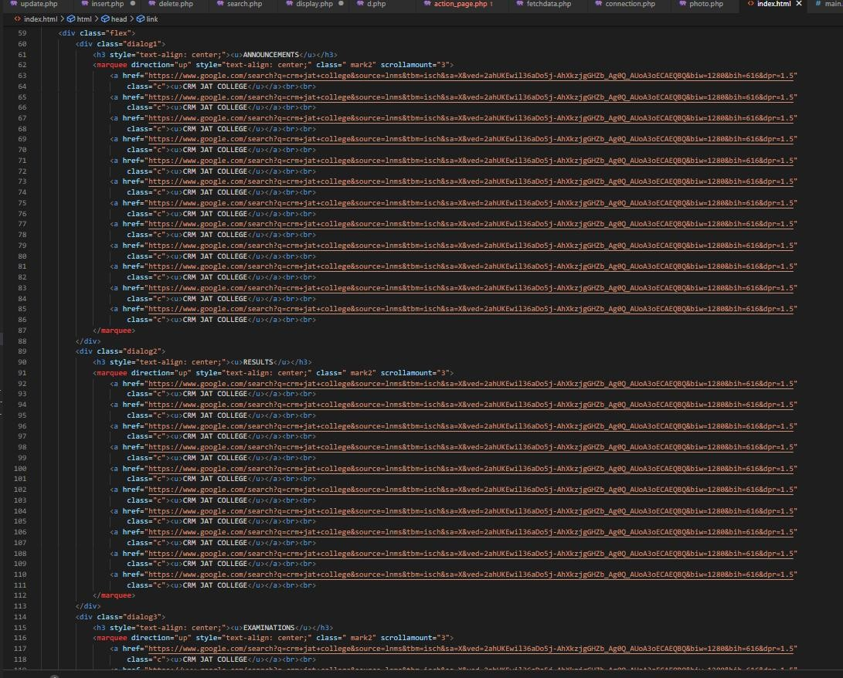

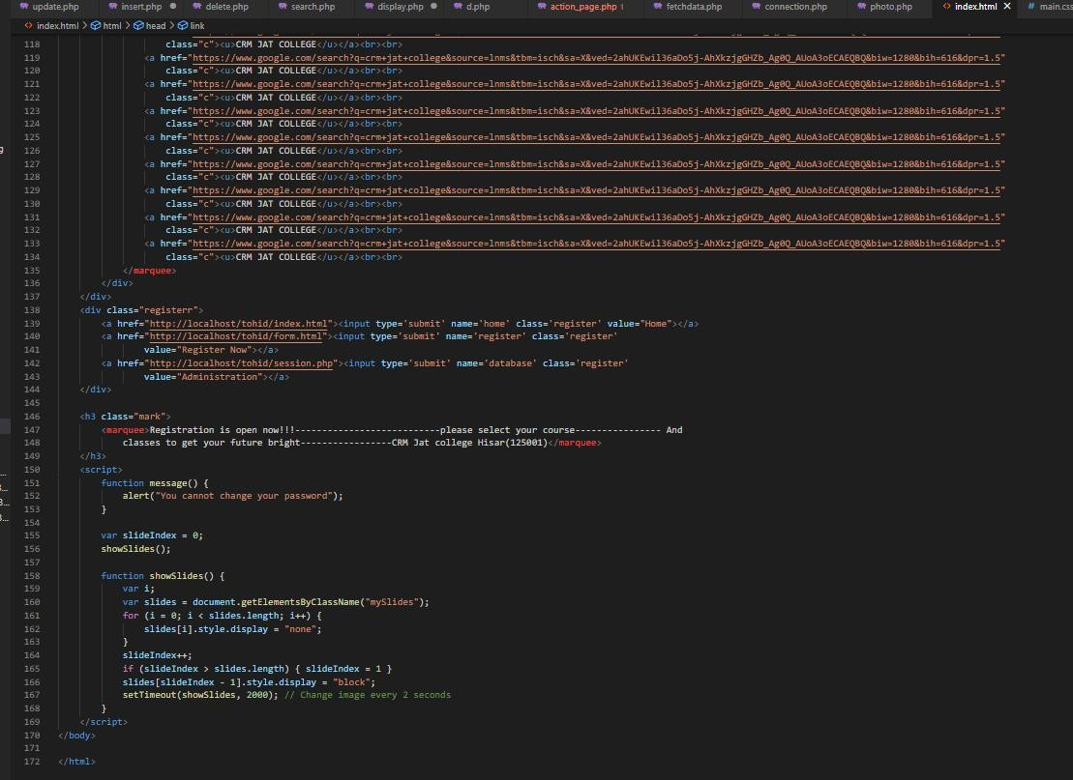

We must need an web browser to check and run codes.

HTML allows images and objects to be embedded and can be used to create interactive forms. It provides a means to create structured documents by denoting structural semantics for text such as headings, paragraphs, lists, links, quotes and other items.

**Output**:-

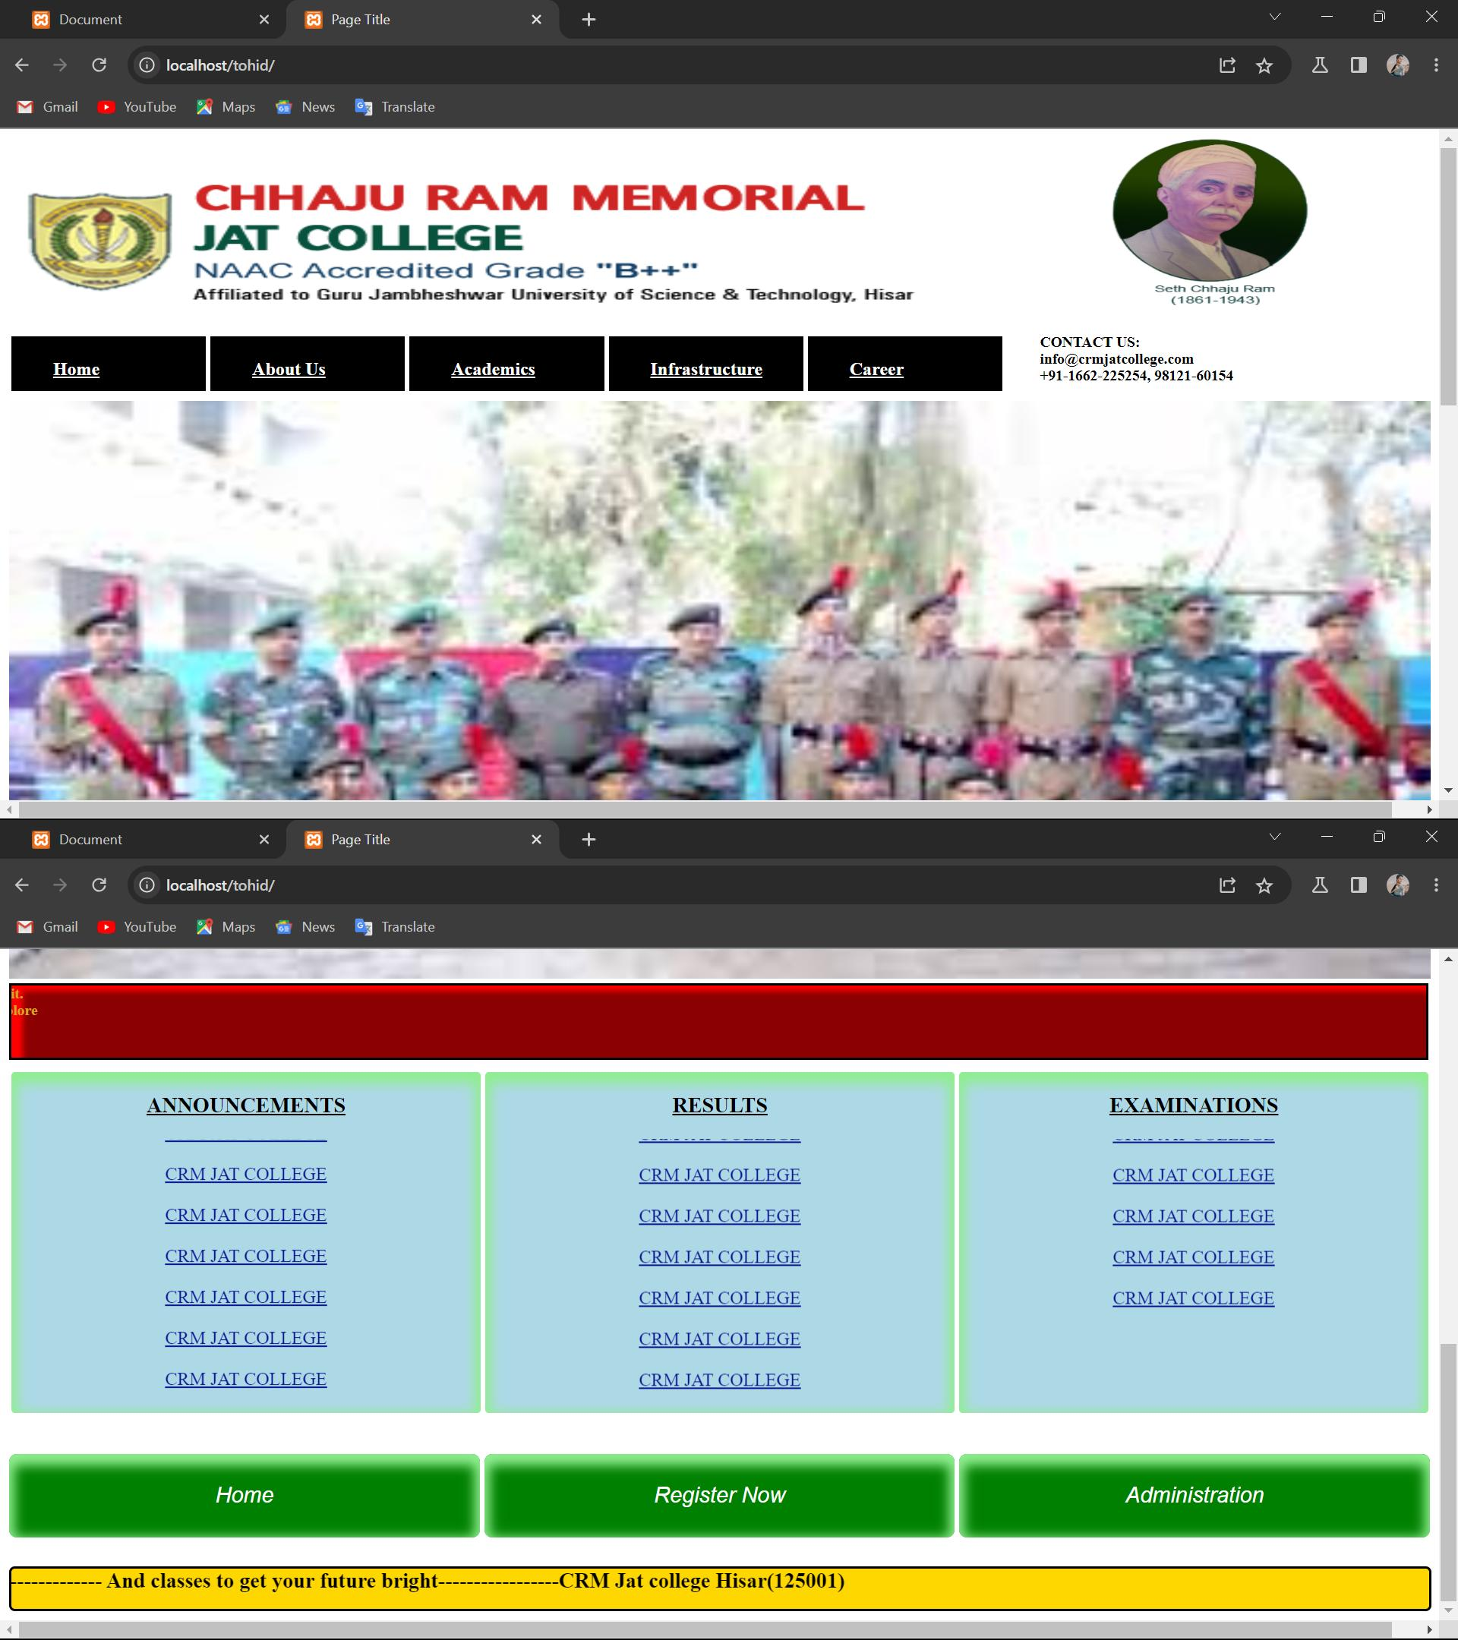



# CSS

Cascading Style Sheets (CSS) is a style sheet language used for describing the presentation of a document written in a markup language. Although most often used to set the visual style of web pages and user interfaces written in HTML and XHTML, the language can be applied to any XML document, including plain SVG and XUL, and is applicable to rendering in speech, or on other media. Along with HTML and JavaScript, CSS is a cornerstone technology used by most websites to create visually engaging web pages, user interfaces for web applications, and user interfaces for many mobile applications.

## Ways to use CSS:

1. Inline :- by using the style attribute inside HTML elements.
2. Internal :- by using a <style> element in the <head> section.
3. External :- by using a <link> element to link to an external CSS file.

**Input**:-

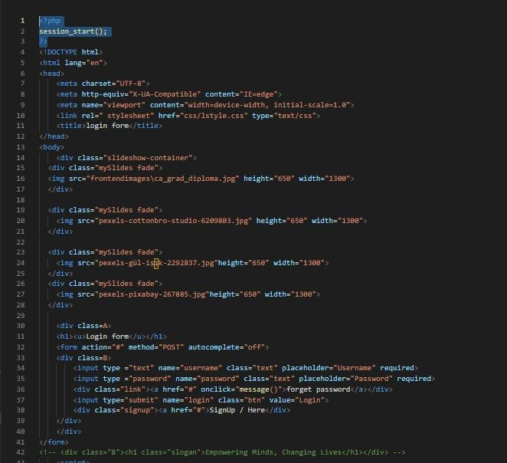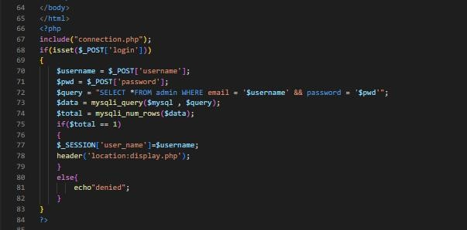

To use CSS we have to use its Tags with specific property. Some of them are :-

* + - <style> :- Defines style information for an HTML document.
    - <link> :- Defines a link between a document and an external resource.
    - {background-color: ;} :- Use to change background color.
    - {color: ;} :- Use to change font color.
    - {font-size: px;} :- Use to increase and decrease the size of font.
    - {font-family: ;} :- Use for different font style (Arial , Times New Roman etc.).
    - <div> :- This tag defines a division or a section in an HTML document.
    - {text-align: ;} :- Use for different text alignment (Left, Center & Right).

**Output:-**

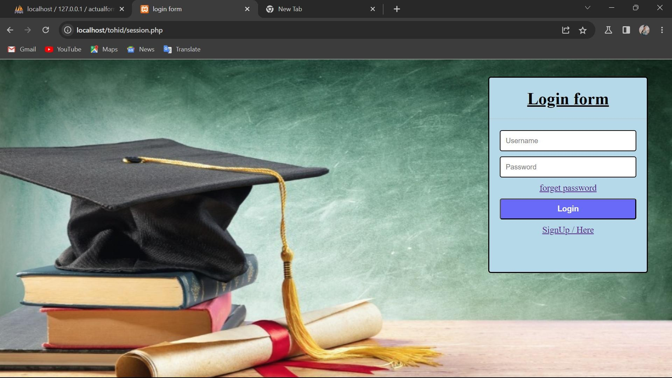



# Java-Script

One of the most widely used programming languages in use today is JavaScript. Create interactive websites and web apps using this high- level, dynamic, and interpreted language. Brendan Eich developed JavaScript in 1995, and ever since, it has become a vital tool for web developers all around the world.

The fact that JavaScript is so adaptable is one of the factors contributing to its popularity. Developers may build full apps using just one language because it can be used for both client-side and server-side development. The fact that JavaScript is lightweight also implies that it loads quickly and uses few resources.

JavaScript's object-oriented programming (OOP) capabilities are another important aspect. As a result, it is simpler to maintain and update code over time because it is organised into reusable objects. In addition, JavaScript includes a sizable library of pre-built modules and methods that programmers can use to swiftly design their apps.

The ability to design interactive and responsive user interfaces is one of JavaScript's key advantages. Developers can add animations, dynamic information, interactive forms, and buttons that respond to user interaction using JavaScript. Web apps become far more interesting and user-friendly as a result.

JavaScript is utilised in a variety of other settings besides web development, including the creation of mobile apps.

# HOSTING

There are many plateform which provide hosting to site. Some of them provide free Hosting and other provide a Paid hosting with a uniqe on demand site name.

Out of these free plateform we use “INFINITYFREE” as a plateform for web hosting . Because it’s provide free hosting and also easy to use as well as easy to maintain.

Infinityfree also provide a database.

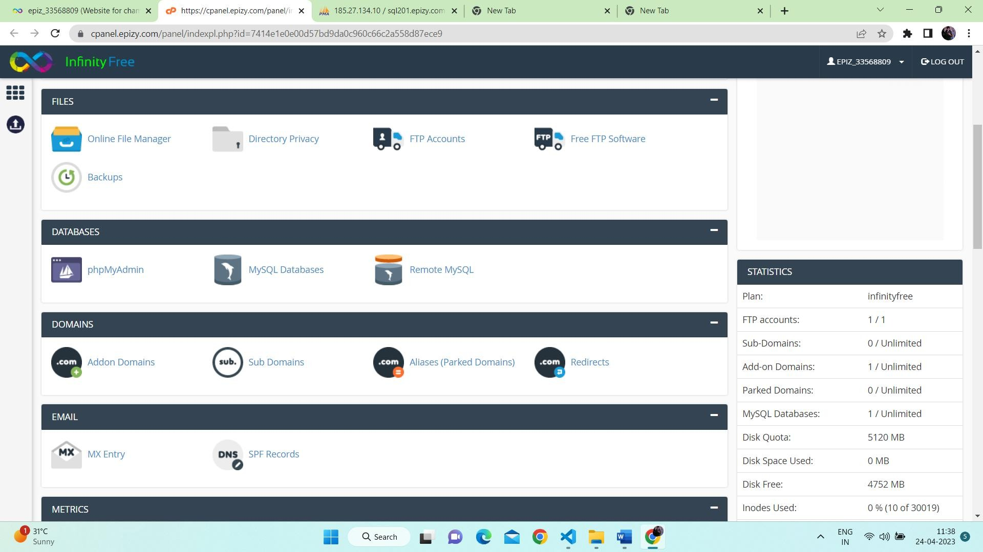

# CONCLUSION

We create this project to provide notes, book, old papers and related video link to study. The student firstly register to over site and then login with their user email and password. After that he/she can access the data. If they have any problem to access to the site, then they can contact us by the provided I’d and contacts.

The user can also provide their notes and books by uploading on over site. By over site the teachers and students group can contact with each other. It helps them to connect get information and guidance for their career.

# FUTURE SCOPE

* + - The development of this project surely prompts many new areas of investigations. This project has wide scope to implement it in any ecommerce websites.
    - This project covers all functionalities related to study material. Hence it can be implemented anywhere else after minute in a click.
    - The sharing facility will be available only to the logged in users.
    - Students can provide there own study material like notes and PDFs to help the other students.

# REFERENCES

* HTML : Thomas A. Powell, Web Designing
* Complete PHP Reference - [PHP Tutorial (w3schools.com)](https://www.w3schools.com/php/default.asp)
* CSS reference- Apna College YouTube Channel and [CSS Tutorial](https://www.w3schools.com/css/default.asp) (w3schools.com)
* Database Management Systems-Third Edition (IE) - Raghu Ramakrishnan, Me Graw Hill Edition, [SQL Tutorial (w3schools.com)](https://www.w3schools.com/sql/default.asp)
* Software Engineering -K.K. Aggarwal and Yogesh Singh
* Hosting Reference- [www.infinityfree.com](http://www.infinityfree.com/)
* Coding Reference- Visual Studio Code

